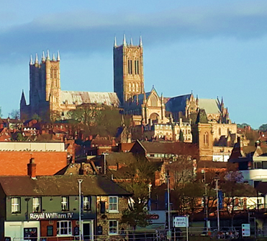**Family News:**

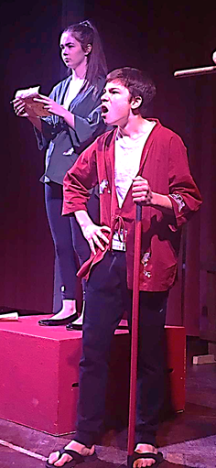**Dan** has been visiting Universities as he considers what he will do after he finishes school in June. We have visited several amazing places, including Lincoln University (left). As we write this, Dan is in Austria on a school ski trip. He and his friend George are planning a mission trip to Kenya in July, working with a Christian couple in the slums of Nairobi before flying to Mombasa to work with another couple in a local school. They are busy raising funds for their trip which includes a table tennis marathon, a quiz night and other initiatives to raise the required funds. He recently turned in a ‘star’ performance in his school play, taking on the role of Dogberry in Shakespeare’s ‘Much Ado About Nothing.’ He quite enjoyed playing the fool.

**Naomi** has accepted a new job working with another Christian Charity called ‘Open Doors’ which works to highlight the plight of the persecuted church. She will be leaving her present job in May, after working with them for the past 8 years. She is excited about the opportunities and challenges this new job will offer. **Phil and Emma** continue to get on well in London – they are beginning to consider moving from their present location and buying a house somewhere. Please pray for wisdom in this.

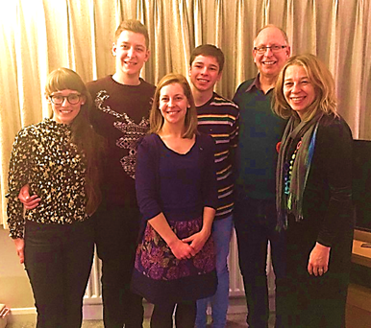Lynn and myself, along with Naomi and Daniel will be back in the US in June this year for a very short visit. We are looking forward to seeing friends and family during our visit and will be speaking at the Antioch Church in Toluca on the 16th June and the Central Church of Christ in Streator, IL on the 23rd June.

We are so very grateful and so wonderfully blessed by your faithful support of the ministry here in the UK. Thank you for your support through prayer, finance and your encouraging words. May you know the peace, joy and love of Jesus in and through the coming months.

**Love from The Allens** (Cliff, Lynn, Naomi, Phil, Emma & Dan)

***London & Southeast Bridge***

36 Beulah Road, Tunbridge Wells, Kent, TN1 2NR Email – [cllyallen@aol.com](mailto:cllyallen@aol.com)

Or c/o Central Church of Christ, 2001 E Main Street, Streator, IL 61364

February 2019

Dear Friends

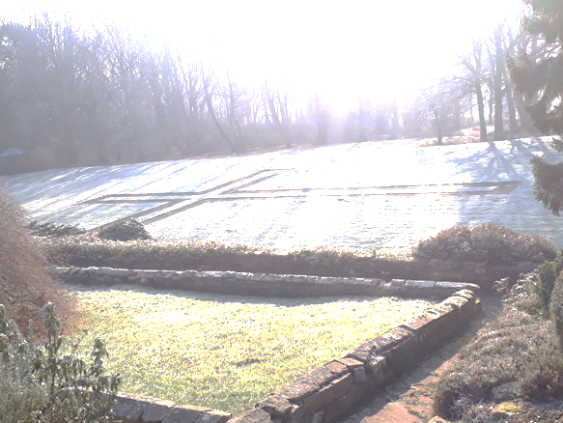Winter is beginning to lose its grip and spring will soon be upon us. We’ve enjoyed some wonderfully frosty mornings, but have been spared any snow accumulation this winter – much to the disappointment of Dan and others who enjoy a good snowball fight and play in the snow. We pray your 2019 has begun well and you know the great joy and blessing of serving our Saviour. Thank you for your faithful encouragement of the ministry here. We hope in these few words we can give you a glimpse of all God is doing among us here in the UK.

**Winter Shelter** – Nearly 30 Churches in the town have joined forces to provide a 9-week emergency winter shelter for those sleeping rough. Besides a bed in a warm, safe environment in a Church hall, a hot meal is provided along with a breakfast. Some churches have shower facilities which the guests appreciate. Other basic health and hygiene provision is offered – barbers, chiropodists, dentists as well as chaplains available to look after the spiritual needs of the guests. Besides the help they receive in the shelter, our support worker works with each of our guests through the week in a variety of ways – helping them apply for housing, or work, or benefits they are entitled to, or find detox treatments for any who have addictions. Nearly 20 different people have made use of the shelter this winter with many of them now housed or on waiting lists for housing and we have had nearly 200 different volunteers helping in a variety of ways to serve some of the most vulnerable people in our town. We pray that besides physical help, each guest will come to know Jesus in their own lives.

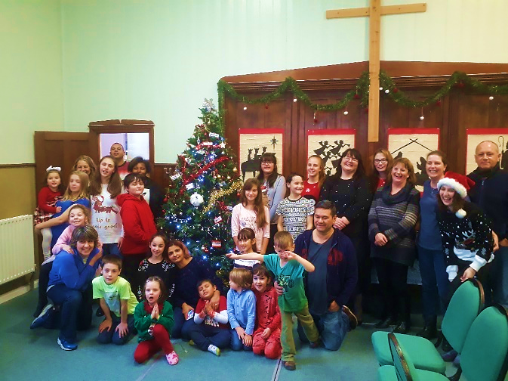**Christmas Reflections**

As always, Christmas was a busy time of year, full of activity and opportunity to share the good news of Jesus Birth.

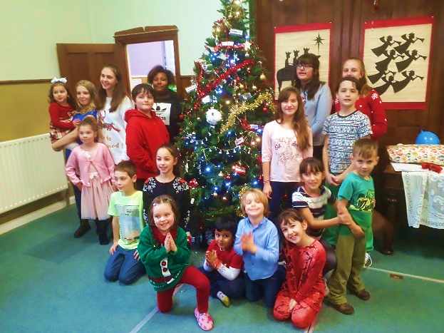 We have been richly blessed over recent months to have assembled a great team of people with a heart for Children’s / Youth ministry. We also have a growing number of children and young people in the church which is such an encouragement. We had a Christmas party for all our young people in the run up to Christmas. Our team of helpers provided food, organised games, planned craft activities and shared the real meaning of Christmas with the children and young people. It was such a joy to sit back and observe the team working together to love, teach and disciple these young lives.

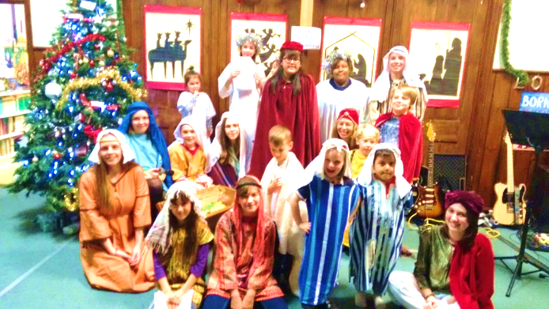Our Carol Service took on the theme ‘Born to Be King’ and featured a play written by one of our church members and performed by a team of youth and young people (Pictured to the left). Nearly 80 people attended from the fringes of the church and from the local community with another opportunity to clearly share the Hope we have in Jesus because of

His Birth, Life, Death and Resurrection.

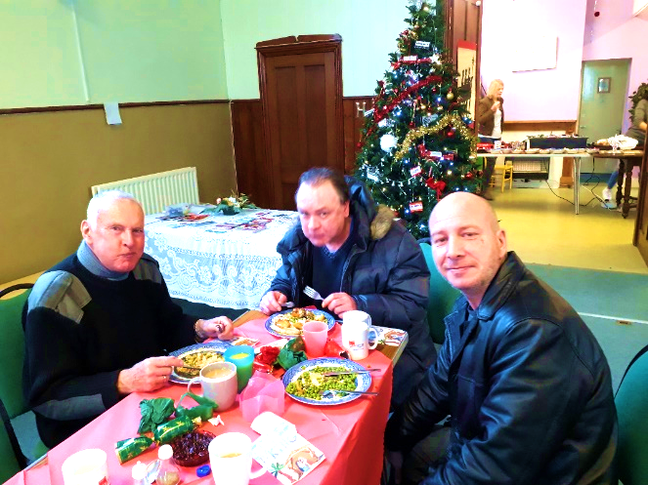We were also able to provide a Christmas Meal for about 20 people who are either homeless, lonely or poor. A festive meal, complete with Carols, gifts and the sharing of the Christmas story was enjoyed by all who attended. Please pray for seeds sown over the Christmas period to take root, grow and bear fruit in the coming months and years.

**New Year**

We began the New Year with times of fellowship as our Church family gathered for a New Year’s Eve Party and also a belated Christmas Meal which saw over 60 people attend. We have been seeking to teach and model being disciples who a) Grow Up in Intimacy with our Father; b) Grow In as we Build Healthy Church Community – living out the ‘one another’ verses in Scripture, and; c) Growing Out as we Bless our local community – where we live, work and play. It’s been encouraging to hear stories over the weeks of opportunities people have had to share their faith, to be Ambassadors for Christ in their daily lives.



**The Bible Course -** We have begun a course which gives a helpful overview of the Bible. We’ve been encouraged with the way in which people have been engaging with this course, those who have quite a depth of Bible understanding as well as those who are just starting out, or are interested in finding out more of what the Bible teaches. A few people have been challenged to begin reading the Bible for the first time in their lives and are finding it helpful and inspiring. Please pray for people to have a hunger for God’s Word.

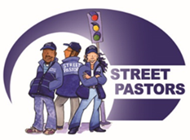

**Street Pastors** - I continue to serve as Chairman of our local Street Pastor Ministry which draws over 25 churches together in sending teams of Christians on to the streets from 10pm – 4am to Listen, Care and Help those in need. It is amazing how often these ambassadors have opportunities to share the love of Jesus in both practical deeds and meaningful words. Next year will mark the 10th year of this ministry in Tunbridge Wells and we are already planning a big celebration.

**150 in 2020** – Speaking of Celebrations, next year will mark the 150th Anniversary of the Church here in Tunbridge Wells. We have gathered a working group to begin to pray and plan for ways in which to mark this occasion in meaningful ways next year.

**Women Creating Community** – Lynn has organised another time of gathering for women of different faiths and none to come together to befriend and share common interests and stories. There has been a great working partnership established between Lynn’s team of Christian ladies and a team of Muslim ladies as trust has been built over these few years. The study that I was engaged in with a few of my colleagues and our local Imam has had to stop for a time due to health issues he was facing. It has given me an opportunity to assure him of our prayers and to drop in various cards during his recovery. We are due to have coffee together in the next few weeks so please continue to pray that in all these relationships, Christ is seen and known.

