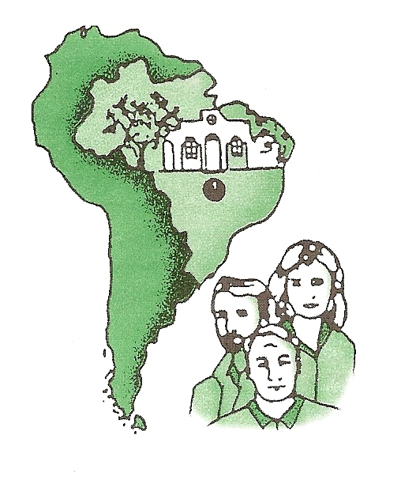
DEAR FAITHFUL C.B.M. PARTNERS AND FRIENDS, JANUARY, 2019

Before you get this we might already be back home in Brazil. The Lord has blessed our time in the U.S. during these past three months. Ruth Anne had a successful operation and recovery but is ready to get back to our ministry on the boat. We both are homesick for the crew and the trips. Ruth Anne spent all of this time at Michael´s while I travelled and visited churches. A special thanks to Michael and Debbie for taking care of us during this time.
The crew has worked hard and made all the necessary repairs on the boat as well as repainted the entire boat. Everything is now ready for the next 9 months as we begin our Amazon Boat Trips on February 12. By the end of October we will have done 11 boat trips.
Here are some praises and prayer requests. We depend so much upon your partnership with us and your prayers.
Praises and Prayer Requests: JANUARY, 2019
1). Ruth Anne is recovering at Michael´s from back surgery
but with normal pain after surgery. Continue to pray for her.
2). 2018 Amazon growth reports: 165 Baptisms and 50 being discipled.
3). CBM Trustee´s meeting at ICOM – very well attended and successful.
4). Faithful CBM partners who pray and support our mission.
5). Earl travelled over 12,000 miles and visited 20 churches during this
short time in the U.S. Thanks for your prayers.
6). Amazon Boat Trips 2019 – 11 trips in nine months.
a). Pray for those churches and groups that will be helping with trips.
b). Pray for safe travel on the rivers and for the boat crew.
7). Amazon missionaries need protection as they travel and visit villages.
8). New regions and villages that will be visited.
9). Michael and our medical student Letícia as they prepare for the future ministries of CBM.
10).Pray for all those involved in the CBM Ministry and Project Amazonas.

Thanks again and please visit our website. www.cbm.org.br You can now donate via our website.
Our 2018 Financial Report is now available upon request.

With much L O V E, we say THANKS,

EARL AND RUTH ANNE

CENTRAL BRAZIL MISSION, INC.

Earl & Ruth Anne Haubner

P.O. Box 420
McCoy, Virginia 24111
Phone: 540-633-2419 or 540-392-7867
Email: mehaubner@gmail.com or cbmhaubner@terra.com.br

