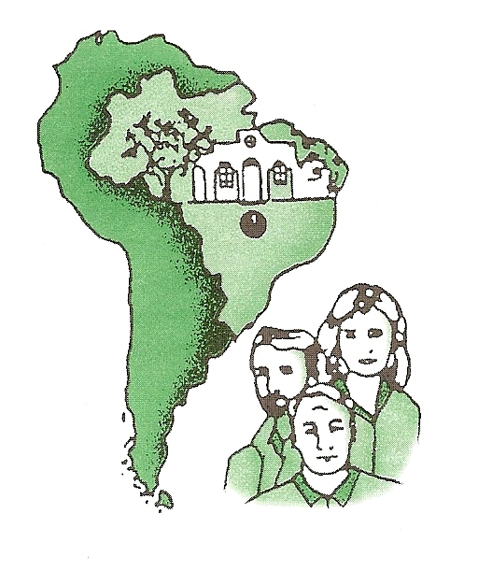
DEAR FAITHFUL C.B.M. PARTNERS AND FRIENDS, NOVEMBER, 2018

Greetings from Goiânia but on our way to the U.S. We will be returning the end of October. Ruth Anne will see a back surgeon on October 29 and will find out what has to be done to get rid of lower back and leg pain. PLEASE BE PRAYING FOR US AND ESPECIALLY FOR HER DURING THESE NEXT FEW MONTHS. We hope to see many of you in Cincinnati at the ICOM Missionary Conference November 15-18. During November, December and January I will be visiting many of our supporting churches giving updates of the Amazon Project: Christ, Life and Health.

During the last seven weeks we did five Amazon Boat Trips, Ruth Anne and I stayed on the boat the entire time. We had excellent trips, being able to visit some new villages and were able to treat over 6,000 individuals. We also saw over 15 baptisms from villages and the São Sebastião Church. Another blessing during this time was to see part of the teams stay in São Sebastião and work at the Greenhouse. A new “Chicken Palace” project was built and is in operation as the Greenhouse expands its ministry. Thanks so much to those who stayed and helped with this project. Also a new foundation was laid for the building of another Greenhouse.

The crew on the boat is wanting and willing to do more trips as we plan to reach new villages with medical/dental help and especially with the new life in Christ. Please visit our website (www.cbm.org.br) for open dates for more Amazon Boat Trips the next few years. We have experimented and we can do trips that are just a week long: Sunday to Sunday. Maybe that will be better for your church or group.

Thanks so very much for being a part of our lives and the CBM Ministry almost 50 years. We are grateful for your prayers and financial support that make possible this mission work.

Please see the page of photos with this letter. And with your help, we will continue…

Working For A Greater Harvest,

Earl, Ruth Anne, Michael, Debbie and Amazon Team

CENTRAL BRAZIL MISSION, INC.

Earl & Ruth Anne Haubner

P.O. Box 420
McCoy, Virginia 24111
Phone: 540-633-2419 or 540-392-7867
Email: mehaubner@gmail.com or cbmhaubner@terra.com.br

